SWEDIMS guidelines

SWEDIMS uses as interface Google Earth Pro®. It can be downloaded at: https://www.google.com/earth/versions/
Please, download the ET0_daily.kmz file from SWEDIMS (http://swedims.se/model-runs.html) and launch it.
It usually takes 3-5 minutes to retrieve all the data from the server (the time to retrieve all the data from the server can vary depending on the internet connection). At the end, you should see as in Figure 1.
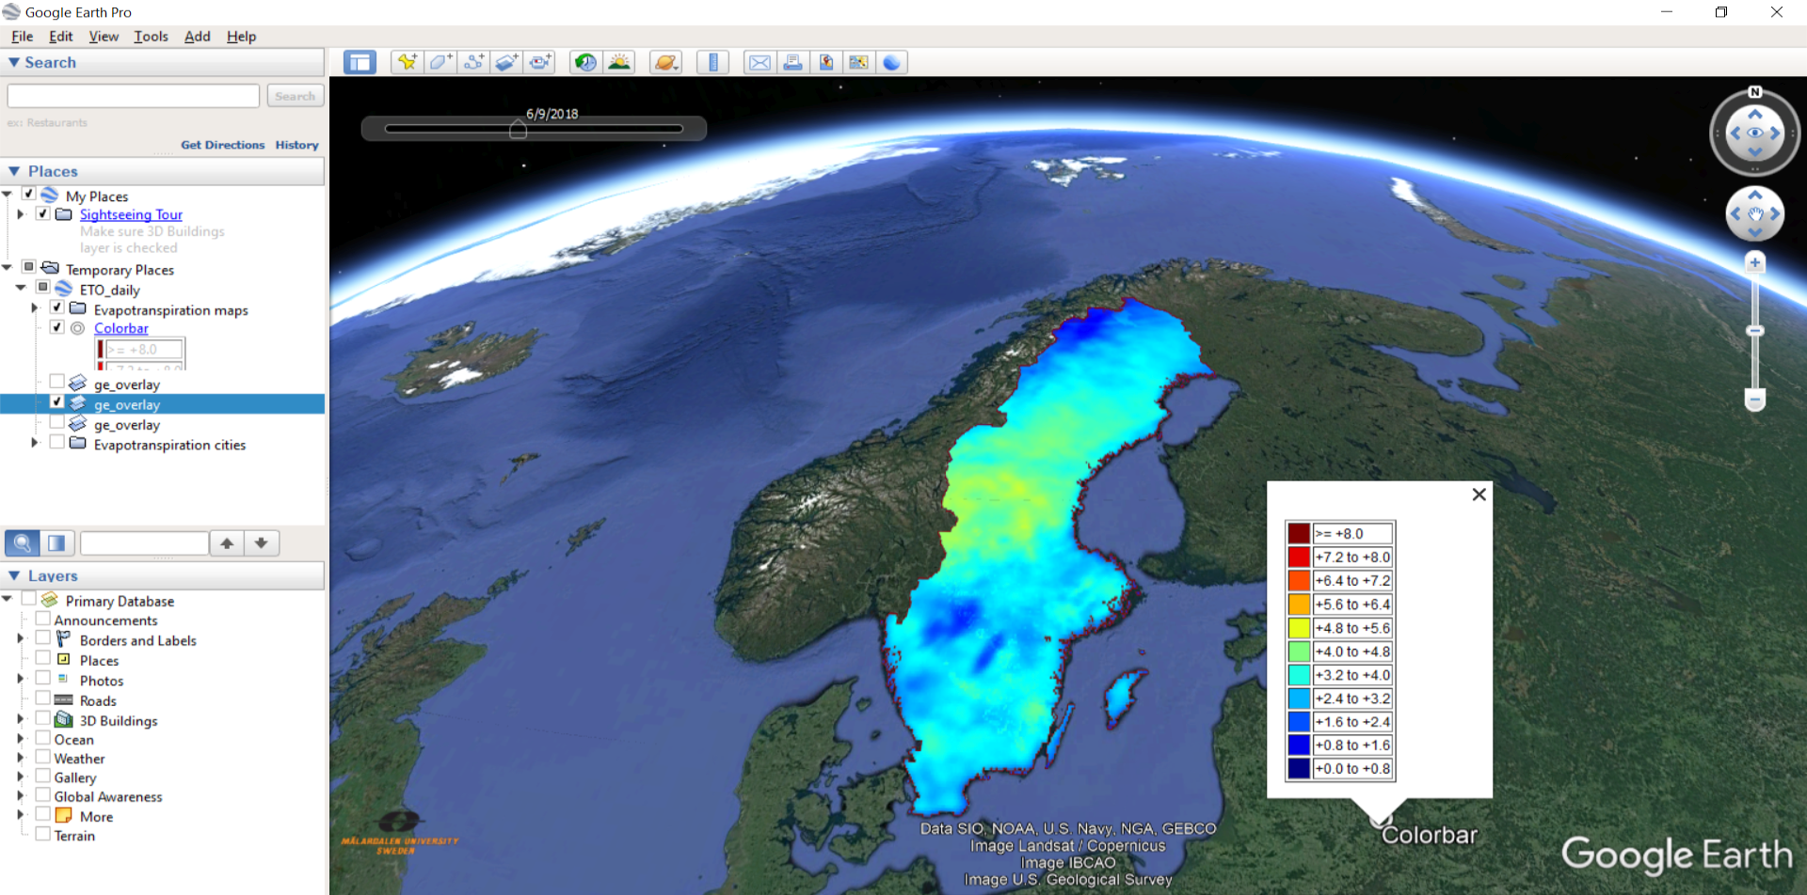
Figure 1: SWEDIMS screenshot.
The file ET0_daily.kmz contains information about:
- daily reference evapotranspiration ET₀ maps for the entire Sweden. Once all the data are retrieved from the server, the maps can be visualized with time dimension by using the time slider, see Figure 2. More information on Google Earth Pro® visualization can be found at: https://www.google.com/earth/versions/
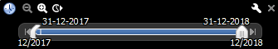
Figure 2: Google Earth Pro® time slider.
- daily based time series of ET₀ and precipitation for about 300 locations across all the country (mark the field Evapotranspiration cities). The locations for which it is possible to retrieve the ET₀ time series will appear on the map. It is enough to click on one location to retrieve from the server the Excel file with the daily time series of ET0 and rainfall as shown in Figure 3.
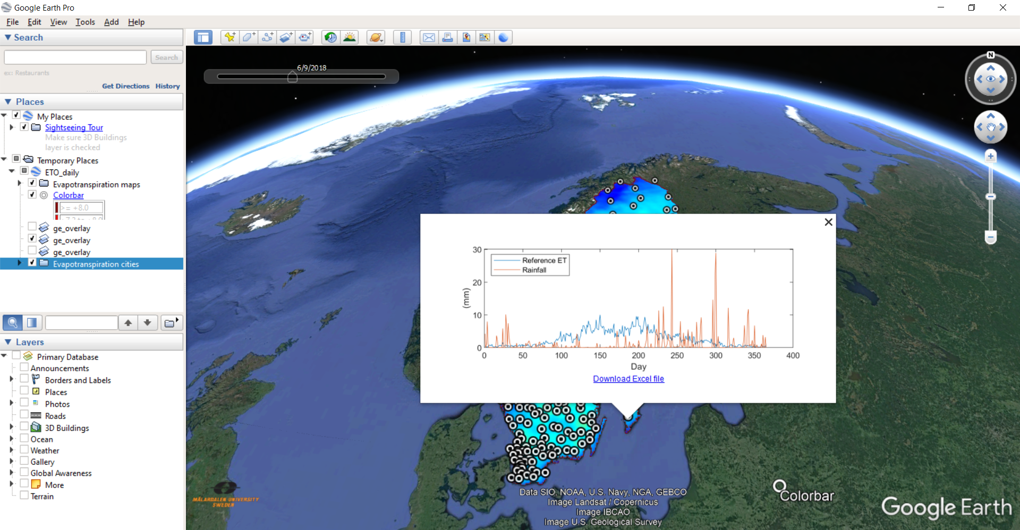
Figure 3: Time series retrieval.

The data concerning ET₀ and rainfall can be used as starting point for more accurate assessment of crop water requirements using the FAO guidelines available at: http://www.fao.org/3/x0490e/x0490e00.htm.

For further information, please contact Dr. Pietro Elia Campana at pietro.campana@mdh.se.

